**GIT Department of Computer Engineering**

**CSE 222/505 - Spring 2022**

**Homework # Report**

**Student Name: Muhammed Alperen Karaçete**

**Student Number: 171044052**

1. **SYSTEM REQUIREMENTS**

User:

Must create an Integer binary tree

Can See Binary Tree’s View

Can See Binary Search Tree’s View

Can See AVL Tree’s View

Can Convert Binary Tree To Binary Search Tree

Can Convert Binary Search Tree To AVL Tree

1. **CLASS DIAGRAM**

Question:1

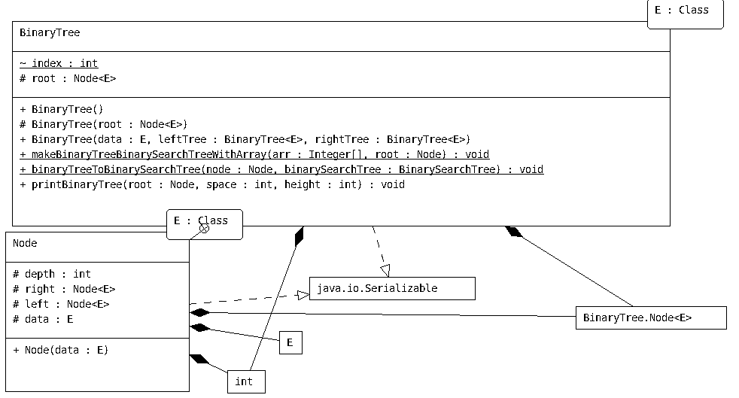

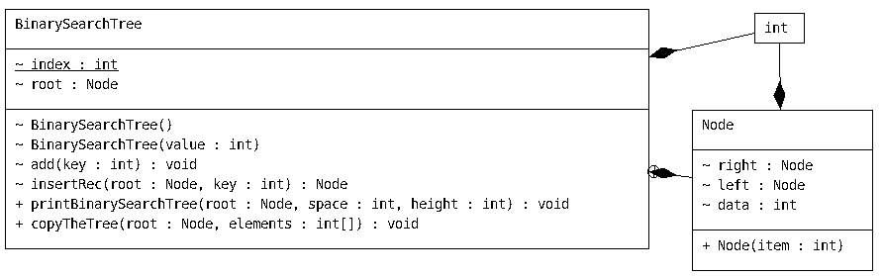

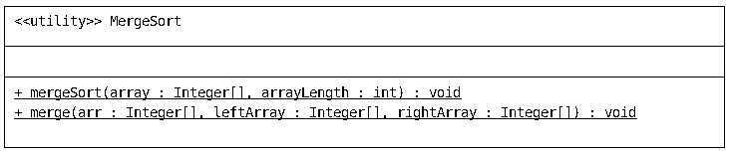

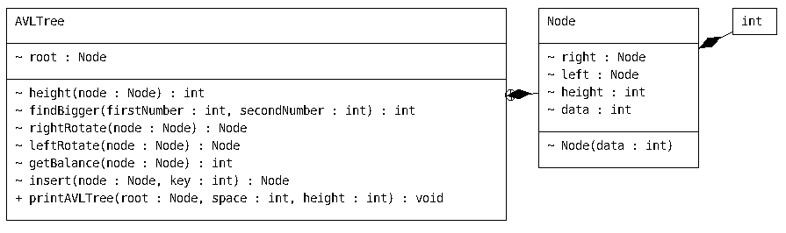Question:2

1. **PROBLEM SOLUTION APPROACH**

Question1:

Firstly, I sorted the elements of array with merge sort algorithm.Then with *makeBinaryTreeBinarySearchTreeWithArray function I changed my binary tree values with array values by using inorder traverse method.With that way my binary tree becomes a binary search tree.Then, with binaryTreeToBinarySearchTree I coppied elements of binarytree to my new binary search tree.In this method.In this method I user preorder traversal method to copy binary tree from root.Then I returned binary search tree.I printed it with my printBinarySearchTree method in driver function.*

Question2:

Firstly I used preorder traversal method to copy elements of binary search tree to array.Then I inserted elements of binary search tree to avl tree.My avl tree insert method check balance on every insertion opereation.There is 4 case for rotation operations.If balance is bigger than 1, and my node left data is bigger than inserted data, then I rotate my subtree right.If balance is smaller than -1, and my node right data is smaller than inserted data, then I rotate my subtree left.If balance is bigger than 1, and my node left data is smaller than inserted data, then I rotate my subtree firstly left, then rotate it to right.If balance is smaller than -1, and my node right data is bigger than inserted data, then I rotate my subtree firstly right, then rotate it to left.With this method, I insert my binary search tree elements my avltree with rotation method.And my tree becomes balanced.

1. **TEST CASES**

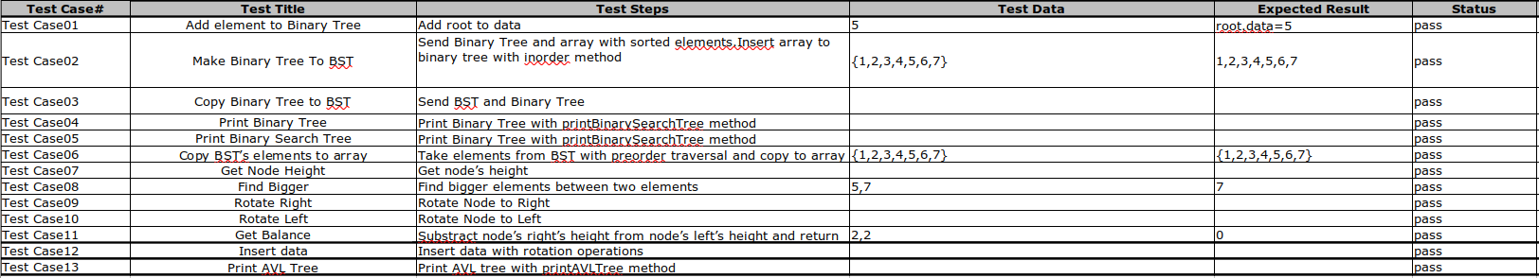

1. **RUNNING AND RESULTS**

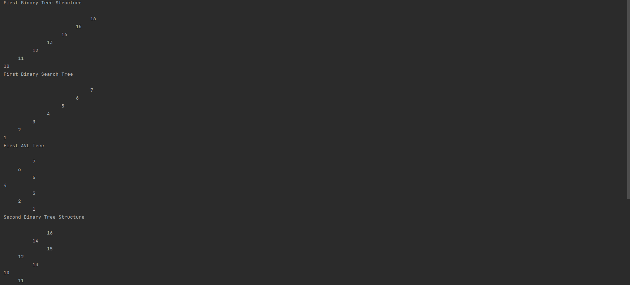

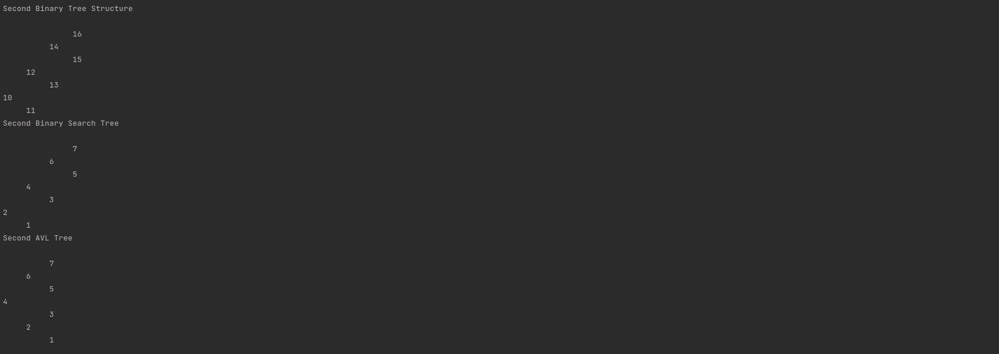

Time Complexity:

makeBinaryTreeBinarySearchTreeWithArrays= O(n) Copies arrays element’s to Binary Tree.

binaryTreeToBinarySearchTree = O(n) Copies Binary Tree’s all elements to Binary Search Tree

copyTheTree = O(n) .Copies all elements of Binary Search Tree To array.